Co-pathology Aβ + α-syn or tau hippocampal injection

Project goals:
- Determine the impact of Aβ on either α-syn or tau co-pathology.
- Determine the differential regional and cellular vulnerabilities to tau and α-synuclein pathology when mice are injected at the same time and same place and how that is altered by Aβ.

Experimental Design
- MAPT (humanized tau) or MAPT/App^{NL-G-F} knock-in mice (not overexpressing tau or Aβ)
- Each genotype injected with α-syn PFF and AD tau separately at 6 months of age
- Mice aged 3, 6, or 9 months post-injection.
- Tau and α-synuclein pathology quantified throughout the brain at all timepoints
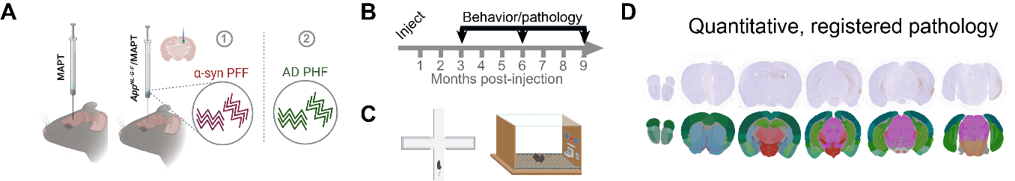
- Aβ42 (total plaque) and Aβ40 (core plaque) quantified only at 9 month post-injection timepoint in injected mice as well as an age-matched non-injected control group.

Network analysis goals:
- Injection sites: CA3, CA1, DG
- Tau and α-synuclein pathology diffusion modeling in 4 groups of mice
  - α-Syn in MAPT compared to MAPT/App^{NL-G-F}
  - Tau in MAPT compared to MAPT/App^{NL-G-F}
- Determine the impact of Aβ load on development of α-synuclein and tau pathologies (fit parameters).
- Beta and gamma estimations and how these are influenced by Aβ

